**KAMPALA PARENTS’ SCHOOL 2004**

**INTERNAL MOCK EXAMINATION-2024**

**P 7 ENGLISH**

**Time Allowed: 2 hours 15 minutes**

|  |  |  |  |  |  |  |  |  |
| --- | --- | --- | --- | --- | --- | --- | --- | --- |
| **Random No.** | | | | | | **Personal No.** | | |
|  |  |  |  |  |  |  |  |  |

**Candidate's Name:** …………………………………………………………………

**Candidate's Signature**: ………………………………………………………………

**Stream:** ………………………………………………………………………………….

**Read the following instructions carefully:**

|  |  |  |
| --- | --- | --- |
| **FOR EXAMINERS' USE ONLY** | | |
| **QN. NO.** | **MARKS** | **EXR'S NO**. |
| 1-10 |  |  |
| 11 - 20 |  |  |
| 21 - 30 |  |  |
| 31 - 40 |  |  |
| 41 - 50 |  |  |
| 51 |  |  |
| 52 |  |  |
| 53 |  |  |
| 54 |  |  |
| 55 |  |  |
| **TOTAL** |  |  |

1. Do not write your **school** or **district name**

anywhere on this paper.

1. This paper has sections: **A** and **B.** Section **A** has **50** questions and Section **B** has **5** questions. The paper has **16 printed pages** altogether.
2. Answer **all** the questions. **All** answers to both sections **A** and **B** must be written in the spaces provided.
3. All answers **must** be written using a **blue** ball point pen or ink. Any work written in pencil will **not** be marked.
4. Unnecessary **changes** in your work and handwriting that cannot be read easily may lead to **loss of marks.**
5. Do not fill anything in the table indicated: **“FOR EXAMINERS' USE ONLY"** and boxes inside the question paper.

**Turn Over**

**SECTION A (50 MARKS)**

**For questions 1 to 5, fill in the blank spaces the most suitable word.**

1. Girls prefer cooking _______________ digging.
2. Our teacher does not punish us and _______________ does our Principal.
3. ______________ had we seen the thief than we alarmed.
4. If Nalule went to the ______________, the mechanics there would repair her car.
5. Dog is to puppy as ________________ is to goats.

**For questions 6 to 15, fill in the blank space with the correct form of the word given in the brackets.**

1. The pupils sat their examination _______________. (noiseless)
2. Malcom _______________ the apples we needed for the party. (buy)
3. The naughty boy ______________ left the dormitory in the morning. (stealthy)
4. Kalungi was charged with the ________________ of cleaning the teachers’ tables. (responsible)
5. Peter and _______________ are great friends at Kampala Parents’ School. (me)
6. Whenever she _______________ a letter, she posts it. (write)
7. Our uncle is an ______________ man in this country. (influence)
8. A friend of theirs is a _______________ national. (Ghana)
9. Most of the _______________ were kind to us. (invigilate)
10. She has never _______________ a formal letter in her life. (write)

**For questions 16 and 17, rearrange the words in alphabetical order.**

1. holidayer, vacationer, beggar, airbus

__________________________________________________________________

1. writing, dealer, setting, sets

__________________________________________________________________

**For questions 18 and 19, rewrite the sentence giving one word for the underlined group of words.**

1. The two pupils sitting an examination who came late completed in time.

__________________________________________________________________

1. The work of catching fish is a well-paying job.

__________________________________________________________________

**For questions 20 and 21, write the full form of the following.**

1. tel. _________________
2. cert. __________________

**For questions 22 and 23, rewrite the sentences giving the plural form of the underlined words.**

1. One of the bench is broken.

__________________________________________________________

1. She ate the avocado alone.

_________________________________________________________________

**For questions 24 to 26, rewrite the sentences giving the opposite of the underlined words.**

1. The thinner of the boys is my cousin.

___________________________________________________________

1. Our teacher is a friend to the Minister.

_________________________________________________________

1. Byaruhanga is as short as Baluku is.

__________________________________________________________________

**For questions 27 and 28, rearrange the sentences to form a correct sentence.**

1. a loving What mother is yours!

____________________________________________________________________

1. I years am twelve old.

____________________________________________________________________

**For questions 29 and 30, use each of the given words in a sentence to show that you know the difference in the meaning.**

1. fair ______________________________________________________________
2. fare ______________________________________________________________

**Sub Section II**

**In each 31 to 50, rewrite the sentences as instructed in brackets.**

1. It will rain heavily in the afternoon. (Use…….likely…….)

__________________________________________________________________

1. Our teacher will speak to us before the examination. (Use…….going to………………..)

__________________________________________________________________

1. There were very few people in the examination room. (Use……hardly…………)

______________________________________________________________________

1. Natooro should write neatly if she wants to pass. (…..ought to………..)

______________________________________________________________________

1. All the pupils in my class are shabby. (Begin: None………………...)

______________________________________________________________________

1. My aunt does not like travelling. My uncle does not like travelling. (Begin: Neither…..nor…)

______________________________________________________________________

1. Kalungi ate fish at the party. Kalungi ate beef at the party. (Use…..not only….)

__________________________________________________________________

1. The P.7 class is made up of two hundred children. (Use:…….consist….)

_______________________________________________________________________

1. She enjoys dancing. She enjoys singing even more. (Use……rather…..)

_______________________________________________________________________

1. Immediately I entered the examination room, the bell rang. (Begin: No sooner…………)

_______________________________________________________________________

1. Anita wrote a nice letter. Anita did not post it. (Begin: Despite……..)

___________________________________________________________________

1. Barbra ate pineapples. Betty ate pineapples. (Use……and so…….)

___________________________________________________________________

1. The candidates are eager to sit their final examination. (Use…. looking forward………….)

_______________________________________________________________________

1. Nakato is a farmer. She is also a teacher. (Begin: Besides……………)

_______________________________________________________________________

1. Kendra said, “Iam looking for my phone.” (Change to indirect speech)

____________________________________________________________________

1. Sofie is two metres tall. Kelly is two metres tall. (Use….as…..as….)

______________________________________________________________________

1. Moreen bought a necklace. It is a nice necklace. The necklace is new and made in China. (Rewrite as one sentence without using any conjunction)

____________________________________________________________________________________________________________________________________________

1. These questions are very easy. (Begin: What……….!)

_________________________________________________________

1. Daddy is not a Sudanese. Daddy is not a Congolese. (Rewrite as one sentence using …………neither…………… nor………….)

__________________________________________________________________

1. It is a long way from Masaka to Kampala. (Use……….far………..)

______________________________________________________________________

# SECTION B: 50 MARKS

1. **Read the passage below and in full sentences answer the questions that follow.**

School holidays are beautiful moments every pupil usually looks forward. There are three school holidays known for every candidate. Out of these three, the third term holiday is the longest.

Below is how I spent my third term holiday last year. We had barely received our report cards when our class teacher, Mr. Zindo Mark gathered us for a briefing. He said that he wanted to speak to us about holiday plans and activities.

We gathered in the school main hall and listened to the advice from our sixty – five-year-old loving teacher of English. In a fatherly tone, he urged us to be careful.

The following morning, I travelled home and immediately wrote my holiday program. I made sure that I balanced both chores and play on my programme. Like the teacher had promised, I enjoyed the holiday like I had never before.

What shocked me however, was to hear that Ambayo Silna, one of my classmates had passed away. She had mysteriously met her death on a fateful night when she had gone drinking with the village boys. On their way home, Ambayo was knocked down by a speeding lorry and that was the end of her.

On hearing the news, I remembered that she was one of the pupils that had not been attentive during the briefing. It is possible that she had not taken the old man’s advice serious. From that time, I have sworn to always have clear and beneficial holiday plans and activities.

**Questions**

1. What is the passage above about?

______________________________________________________________

1. How many school holidays are talked about in the passage above?

______________________________________________________________

1. Of the holidays mentioned, which one is the longest?

______________________________________________________________

1. Who was the writer’s teacher of English according to the passage?

____________________________________________________________________________________________________________________________

1. Why do you think the writer’s class teacher gathered them for a briefing?

_____________________________________________________________

_____________________________________________________________

1. How old was the writer’s class teacher?

_____________________________________________________________

1. What shows that the writer took the old man’s advice serious?

____________________________________________________________________________________________________________________________

1. Which pupil did not plan well for their holiday?

______________________________________________________________

1. How did Ambayo Silna meet her death?

______________________________________________________________

1. What lesson do you learn from the passage above?

______________________________________________________________

1. **The information below was found pinned on the noticeboard of Kabuuti Primary School in Mbale District on 16th October 2023.**

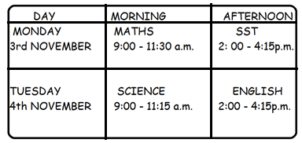

**Questions**

1. What is the information above called?

_____________________________________________________________

1. Which subject was done first according to the timetable?

_____________________________________________________________

1. How many subjects are indicated above?

______________________________________________________________

1. When was English done?

______________________________________________________________

1. At what time did the second paper on Monday end?

______________________________________________________________

1. What time of the day was the Science paper written?

_______________________________________________________________

1. For which year was the above information?

______________________________________________________________

1. Where could one find such information?

_______________________________________________________________

1. Why do you think the above information is important to the candidates?

______________________________________________________________________________________________________________________________

1. On what date was the SST paper written?

_______________________________________________________________

1. **The sentences below are in wrong order, rearrange them to form a good composition.**
2. Kawere Primary School is a busy School.
3. We look forward to seeing everybody there.
4. It will take place on 7th Saturday and 8th Sunday October.
5. It is being prepared by the music, Dance and Drama teachers.
6. In term three, swimming is the song.
7. However, this year 2024, term two will be the school production.
8. Music takes place in term one and sports in term two.
9. Each activity is done termly.
10. This is because it does many school activities.
11. Some of the activities include music, sports and swimming.

**_______________________________________________________________________________________________________________________________________________________________________________________________________________________________________________________________________________________________________________________________________________________________________________________________________________________________________________________________________________________________________________________________________________________________________________________________________________________________________________________________________________________________________________________________________________________________________________________________________________________________________________________________________________________________________________________________________________________________________________________________________________________________________________________________________________________________________________________________________________________________________________________________________________________________________________**

1. **Read he poem below carefully and then answer in full sentences the questions that follow.**

Dear candidate,

The time has come

For timetable already up on the noticeboard.

Success is all we wish you.

Dear candidate,

As you enter the examination room

Please remember to write

Not only your name

But also your random number

These help in identification

Dear candidate,

You have been taught well

All you need is to write well

Read the questions carefully as they are tricky

And punctuate your work

With these, success is all yours

**Monday Mosh P.7**

**Questions**.

1. What is the poem above about?

_______________________________________________________________

1. Who is being addressed in the poem?

_______________________________________________________________

1. Where is the timetable according to the poem?

______________________________________________________________

1. Why does the candidate read the questions?

______________________________________________________________

1. How many stanzas are in the poem?

______________________________________________________________

1. Apart from the name, what else should the candidate write?

_______________________________________________________________

1. In which stanza does the speaker wish the candidate success?

______________________________________________________________

1. Suggest a suitable title to the above poem.

______________________________________________________________

1. Who wrote the poem?

_____________________________________________________________

1. How many lines does the poem have?

_____________________________________________________________

1. **The pictures A - F tell a story. Study them and write one sentence to describe what is happening in each picture. You may use any of the following words to help you.**

|  |
| --- |
| **riding, careless, boys, holding, hospital, mother, rolling, bicycle, speeding, accident, excited, sending, injured** |

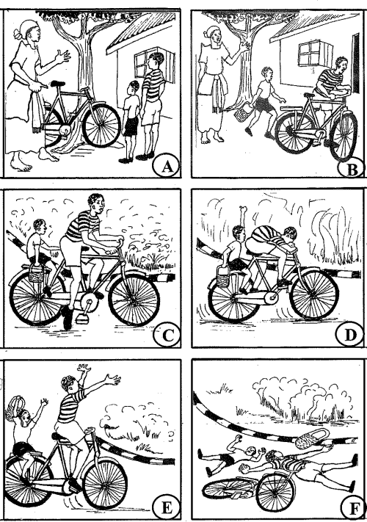

1. Picture **A ___________________________________________________ ___________________________________________________________**
2. Picture **B ____________________________________________________**

**____________________________________________________________**

1. Picture **C ____________________________________________________**

**___________________________________________________________**

1. Picture **D ____________________________________________________**

**___________________________________________________________**

1. Picture **E ____________________________________________________**

**___________________________________________________________**

1. Picture **F ____________________________________________________**

**___________________________________________________________**

1. Where did the boys begin riding the bicycle?

____________________________________________________________

1. What do you think caused the accident?

____________________________________________________________

1. What do you think happened to the boys after the accident?

________________________________________________________________________________________________________________________

1. Give a suitable title to this picture story

____________________________________________________________

**\*\*\*\*All The Best\*\*\*\***